

Minutes of the Full Council Meeting on Monday 14 September 2026 at 7pm

Held at the Wilton Baptist Church

Members Summoned and Present: Cllr Angela Alexander, Cllr Charlotte Blackman, Cllr Gary Blandford-Hull, Cllr Alexandra Boyd, Cllr Michelle Ditton, Cllr Peter Edge, Cllr Claire Forbes, Cllr Chris Harrison, Cllr Maria La Femina, Cllr Phil Matthews and Cllr Mick Whillock
Absent: None

Officers Present: Brie Logan (Town Clerk), Neil Durrant (Communications Officer).

In attendance:
Cllr Pauline Church (Wiltshire Council)

Press (0), Members of the Public in-person (16) online (5), Police (0)

The chair advised members and the public that the meeting was being recorded.

Public Participation
- A representative of Netherhampton Parish Council requested support for a CIL funding application for a new footpath between Netherhampton and Quidhampton. The matter was subsequently considered under agenda item 12.3.4 and minute reference FC60.
- A resident expressed disappointment that Option 1 for the car park design had been discounted and asked why a 12-metre turning circle was considered necessary; whether land to the left of the entrance could provide additional parking; whether tarmac might develop potholes because of the ground conditions; whether heavy-duty plastic grids had been considered; and whether the four additional spaces under Option 3 justified the effect on the wildflower area.
These questions were deferred for discussion under agenda item 7.
- A resident commented on the wildflower “strip” and how it has a range of plants within the wildflower area and stated that it should be protected from further encroachment for parking purposes.
- A resident noted that Castle Meadow is situated within a conservation area and expressed the view that high-level car park lighting would be inappropriate. The resident stated that users had not requested additional parking, that monitoring had indicated that existing parking was generally adequate and that consideration could be given to improving the turning space at the end of the car park. The resident also requested that the supporting reports and other relevant documents be made available alongside the Council’s decision.
- Another resident echoed all of the above comments concerning Castle Meadow.
- A representative from the Men’s Shed referred to the storage containers in compound stating they need to be accessible at ground level to allow materials and equipment to be moved in and out without having to negotiate steps.
- A Councillor referenced a photo that she had been given from a member of the public, from a social media platform she isn’t on, expressing concern that Castle Meadow was sprayed with something stating that no warning signage or fencing was evident.
It was explained that a contractor appointed by Wiltshire Wildlife had attended Castle Meadow to undertake treatment of Japanese knotweed. The Council had received limited prior notice and had therefore had insufficient time to issue advance public information.

The meeting started at 7:12 pm

FC53 Apologies

Officer report 0926FC01 was received.
There were no absences to report.

FC54 Declarations of Interest

Officer report 0926FC02 was received. It was NOTED that Councillors should declare any interests if
they arise during the meeting.

No other declarations were reported.

FC55 Minutes

Officer report 0926FC03 was received.
A request was made to clarify that the reference to toilet access related to the toilets within Wilton Baptist Church, rather than Wilton’s public toilets.

Proposed by Cllr Edge and seconded by Cllr Matthews it was RESOLVED to adopt the minutes from the Full Council meeting on 10 August 2026 with the above amendment.

The motion was carried by 11 votes in favour, 0 against and 0 abstentions.

FC56 To receive a report for information to Full Council

Officer report 0926FC04 was received and noted.

Civic Report
Cllr Harrison reported that he has selected Salisbury Hospice’s Fund a Nurse campaign as the Mayor’s chosen charity.

He advised that he and Cllr Blackman will be taking part in the Midnight Walk on 19 September and
encouraged members and residents to support the fundraising effort. The event was recently promoted
on Radio Odstock.

Cllr Harrison also reported that he had attended the Wilton Bears home fixture against Amesbury on
Saturday 12 September. Wilton won the match 3–1. He noted that 33 vehicles had been parked at the site
and that access into and out of the car park had been obstructed.

Wiltshire Council
Cllr Church reported that Wiltshire Council's Household Recycling Centre booking system pilot, which
includes Salisbury Household Recycling Centre, is now live. Residents wishing to use the Salisbury site are
required to book a 30-minute slot in advance, either online or via the MyWilts app.

Members were reminded not to place items on the "swap" bench located in North Street, as items left
outside the designated arrangements may constitute fly-tipping. The maximum fixed penalty for fly-
tipping has increased to £5,000 in line with Government guidance.

Cllr Church advised of a proposed road closure from Stratford-sub-Castle to the Netherhampton junction with the A3094, scheduled from 6 to 14 October. She noted that the dates might be subject to change.

She also reported that Wilton Fire Station had experienced a particularly busy summer period due to the
hot weather. Members were advised that the Wilton Food Bank has now closed, although plans are in
place for the Wilton Pantry to open in the future.

Cllr Church noted that parking charges across Wiltshire had increased by 20% from the beginning of
September, with the exception of Wilton. Sunday parking charges are now aligned with weekday charges,
except for on-street parking spaces.

Members were advised that applications for school places for the 2027/2028 school year were open. Flu
vaccination bookings were open for eligible residents, including those aged over 65, through the NHS app.

Cllr Church further reported changes to the planning system, whereby Wiltshire Councillors no longer
have the ability to call planning applications to the planning committee. Smaller applications, generally
those involving fewer than ten dwellings, would be determined under delegated powers by planning
officers, while strategic residential and commercial applications would follow a gateway process involving
planning officers and the Chair of the Planning Committee.

Cllr Church reported that, at the most recent Wiltshire Council meeting, she had raised concerns about a
perceived conflict between the Leader’s strategic planning responsibilities and his ownership of a planning
consultancy. It was noted in response that the Leader had stated that he had not undertaken consultancy
work within Wiltshire. Cllr Church maintained that her concern related to public perception rather than an
allegation of wrongdoing. She reported that 48 councillors had voted in support of the Leader.

Cllr Church reminded members that the Local Plan Scoping Consultation remains open until 30 September
2026 and encouraged both local councils and residents to consider potential sites for inclusion within the
emerging Local Plan.

Member Questions
Cllr Matthews requested that the condition of the box junction markings on Silver Street be monitored, as
it was considered that remarking may soon be required.

Cllr La Femina sought clarification regarding the Local Plan Scoping Consultation and whether sites could
be promoted through the Call for Sites process where the Town Council was not the landowner.

It was confirmed that the Call for Sites process can include any land irrespective of ownership.

Wiltshire Police - the Police were not in attendance however the August report had been provided.

Wilton United Charities

Cllr Edge reported that, due to ill health, the Chairman and Treasurer of Wilton United Charities had

stepped down from those roles. The charity would consider the immediate arrangements at its

forthcoming meeting and would be seeking a replacement trustee and/or Chair.

FC57 To receive financial reports and approve payments
Officer report 0926FC05 was received.

Proposed by Cllr Matthews and seconded by Cllr Ditton it was RESOLVED to receive and note the bank reconciliation, year-to-date receipts and payments against budget and the monthly breakdown by cost code.
The motion was carried by 11 votes in favour, 0 against and 0 abstentions.

Proposed by Cllr Edge and seconded by Cllr Matthews it was further RESOLVED to ratify payments to the value of £37,464.26 and to approve the payments to Blachere Illumination of £6,666.00 and £7,112.00 plus payments to Signs of the Times for £4,442.50 and RE Hayes for £3,559.71 and £150.00.

The motion was carried by 11 votes in favour, 0 against and 0 abstentions.

Summary of Reconciliation and Cash in Hand (as at end August 2026)

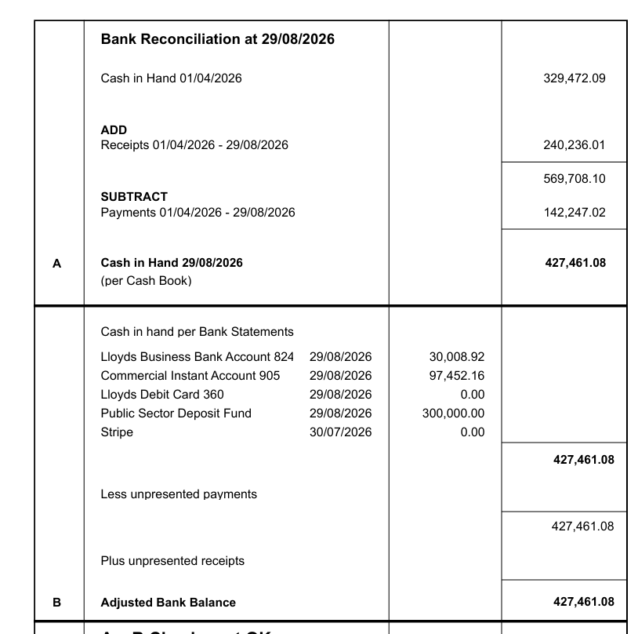

Summary of Payments (August 2026)
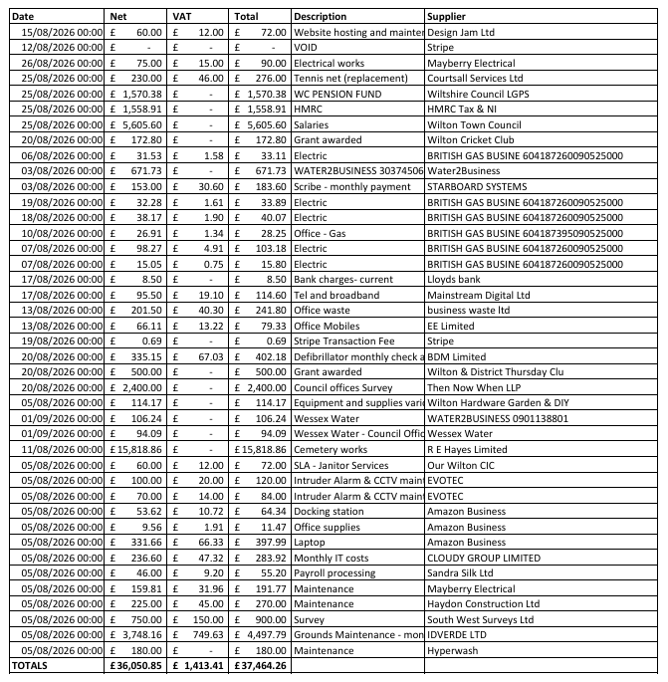

FC58 To consider and comment on planning applications

Officer report 0926FC06 was received.
Application: PL/2026/04897
Proposal: Notification of proposed works to trees in a conservation area. Proposal: Tamarix - Fell.
Location: 20 NORTH STREET, WILTON SP2 0HE
Consultation: 16 September 2026
Proposed by Cllr Edge and seconded by Cllr Whillock it was RESOLVED to SUPPORT the application
The motion was carried by 11 votes in favour, 0 against and 0 abstentions.

Application: PL/2026/04333
Proposal: Householder application to: Replace existing conservatory with flat roofed single storey rear
extension extending new flat roof over existing store and single storey side extension.
Location: 33 WATER DITCHAMPTON, WILTON SP2 0JB
Consultation: 16 September 2026 (deadline extension approved)
Proposed by Cllr Harrison and seconded by Cllr Edge it was RESOLVED to SUPPORT the application with the comment that this increase to the property footprint may increase risk of flooding in a known flood risk area.
The motion was carried by 11 votes in favour, 0 against and 0 abstentions.

Application: PL/2026/05356
Proposal: Notification of proposed works to trees in a conservation area. Proposal: G1 - group of Cypresses and Leylandii trees - reduce to 4m G2 - 4 x Leylandii trees - reduce to 4m.
Location: 117 NORTH STREET, WILTON, SP2 0AJ
Consultation: 15 September 2026
Proposed by Cllr La Femina and seconded by Cllr Edge it was RESOLVED to SUPPORT the application
The motion was carried by 11 votes in favour, 0 against and 0 abstentions.

FC59 Castle Meadow Car Park and Compound Project: to consider car park design options and next steps

Officer report 0926FC07 was received and considered.

Cllr Blackman proposed that the Council approve Option 3 as set out within the reports contained within the agenda. The motion was seconded by Cllr Edge.

Cllr La Femina proposed an amendment that the turning circle within the design be replaced with a
reversing bay/turning area, in order to reduce the potential for the dead-end section of the car park to
become obstructed by additional vehicles. The amendment was seconded by Cllr Boyd.

At the request of Cllr La Femina, a recorded vote was taken on the amendment.

Recorded vote
In Favour | 2 | Cllrs Boyd and La Femina
Against | 9 | Cllrs Alexander, Blackman, Blandford-Hull, Ditton, Edge, Forbes, Harrison, Matthews and Whillock
Abstentions | 0
Motion failed

The Meeting was adjourned at 19:55 for a comfort break.
The Meeting resumed at 20:03.

Substantive motion – Proposed by Cllr Blackman and seconded by Cllr Edge it was RESOLVED to:

- note the evidence considered and the recommendation made by the Castle Meadow Compound and Car Park Project Group;
- approve Option 3 in principle as the Council’s preferred option for the Castle Meadow compound and car park project;

Recorded vote
In Favour | 9 | Cllrs Alexander, Blackman, Blandford-Hull, Ditton, Edge, Forbes, Harrison, Matthews and Whillock
Against | 2 | Cllrs Boyd and La Femina
Abstentions | 0
Motion carried

Proposed by Cllr Edge and seconded by Cllr Whillock it was RESOLVED to:

- delegate authority to the Town Clerk, working in collaboration with Cllr Blandford-Hull, the Chair of the Flood and River Management Advisory Committee, the appointed civil engineer, Edenvale, and Marshway Construction, to develop the technical details of Option 3; and to appoint Chris Boot, representing the Men’s Shed, to the project group.

Recorded vote
In Favour | 10 | Cllrs Alexander, Blackman, Blandford-Hull, Boyd, Ditton, Edge, Forbes, Harrison, Matthews and Whillock
Against | 0
Abstentions | 1 | Cllr La Femina
Motion carried

Proposed by Cllr Boyd seconded by Cllr Blandford-Hull it was RESOLVED to:

- agree that any material change to the layout, scope or anticipated cost, together with any required financial or procurement approval, must be referred back to Full Council.

Recorded vote
In Favour | 11 | Cllrs Alexander, Blackman, Blandford-Hull, Boyd, Ditton, Edge, Forbes, Harrison, La Femina, Matthews and Whillock
Against | 0
Abstentions | 0
Motion carried

FC60 - Netherhampton Parish Council’s CIL Request
Agenda Item 12.3.4 was brought forward at the discretion of the Chair

Proposed by Cllr Edge and seconded by Cllr Matthews it was RESOLVED to formally support the proposed footpath between Netherhampton and Quidhampton, and delegate the Town Clerk to provide a letter of support for inclusion with the CIL funding application.

The motion was carried by 11 votes in favour, 0 against and 0 abstentions.

FC61 To consider the Wiltshire Local Plan – Historic “Call for Sites” and Site Submission Review

Officer report 0926FC08 was received.

Proposed by Cllr Edge and seconded by Cllr Forbes it was RESOLVED to include S138, Land at The
Avenue/Depot, and S1057, Land to the rear of Bulbridge and the wider Bulbridge area, in the Council’s
response to Wiltshire Council’s current Call for Sites exercise; and to place potential asset transfer of Sheep
Fair Field on the October Full Council agenda for consideration.

The motion was carried by 11 votes in favour, 0 against and 0 abstentions.

Cllr Matthews left the meeting at 8:19pm

FC62 To consider the findings of the officer assessment of practical access arrangements at Wilton Baptist Church

Officer report 0926FC09 was received.

Proposed by Cllr Harrison and seconded by Cllr Blackman it was RESOLVED that the Town Clerk, together
with Cllrs Boyd and La Femina, meet representatives of Wilton Baptist Church to discuss the access
concerns raised and any further reasonable and proportionate adjustments that the Church might consider.

The motion was carried by 10 votes in favour, 0 against and 0 abstentions.

FC63 To consider planning for an Emergency Contact Hub in Wilton

Officer report 0926FC10 was received.

Proposed by Cllr Edge and seconded by Cllr Blandford-Hull, it was RESOLVED to:

- approve, in principle, the establishment of an Emergency Hub for Wilton;
- establish a project group to develop a detailed Emergency Hub Plan, including the proposed location, purpose, operating arrangements, resources, responsibilities and any financial implications;
- nominate Cllr Ditton and Cllr Forbes to serve on the project group; and
- present the completed Emergency Hub Plan to Full Council for consideration and approval before implementation.

The motion was carried by 10 votes in favour, 0 against and 0 abstentions.

FC64 To consider the costs of replacing the missing sections of railings at the Cemetery

Officer report 0926FC11 was received.

Proposed by Cllr Alexander and seconded by Cllr Ditton, it was RESOLVED to:
- note the quotations received and the reasons for the revised cost relating to Contractor A; and
- approve the appointment of Contractor A [Ian Thackery Blacksmith] at a cost of £3,500+VAT, with the additional expenditure above the previously agreed £3,000 budget funded from EMR Cemetery – cost code 9001.

The motion was carried by 10 votes in favour, 0 against and 0 abstentions.

FC65 Clerk’s Report including correspondence and progress report on Full Council business

Officer report 0926FC12.1 was received, and the following points were NOTED:

- Community Governance Review:
Members discussed whether the Wilton Parish boundary might be extended to include Ugford, which currently lies within Burcombe Parish. It was agreed that the Clerk would contact Burcombe Parish Council to establish whether there was interest in the proposal and, subject to the outcome of those discussions, submit the Town Council’s response to Wiltshire Council by the deadline of 1 October 2026.

- Football Pitch & Grounds Maintenance: received and noted

- External Audit: Notice of Conclusion of audit now received and AGAR Section 3 will be included in the October Full Council agenda.
- Event Road Closures for Remembrance Sunday and the Christmas Event: Received and noted

FC66 Officer report 0926FC12.2 was received and noted.

Proposed by Cllr Ditton and seconded by Cllr La Femina it was RESOLVED to ratify the clerk’s delegated expenditure as follows:

12.2.1 | Glasdon bin project | £636.95 + VAT
12.2.2 | Uplighters, Old St Mary’s Churchyard | £1,481.76 + VAT
12.2.3 | Tree works at Cemetery | £1,560.00 + VAT
12.2.4 | Flood Warden PPE | £991.23 + VAT
12.2.5 | Christmas Event Medical & Security Cover | £476.00 + VAT
12.2.6 | Football Pitch Treatment | £872.88 + VAT

The motion was carried by 10 votes in favour, 0 against, 0 abstentions.

FC67 Officer report 0926FC12.3. was received.

- Officer Overtime
Proposed by Cllr Ditton and seconded by Cllr Forbes it was RESOLVED to authorise payment for the 26 additional officer hours incurred in processing the three Freedom of Information requests at a cost of £671.

The motion was carried by 10 votes in favour, 0 against and 0 abstentions.

- Public WC Project – Joint Contracts Tribunal (JCT) Contract
Proposed by Cllr Blandford-Hull and seconded by Cllr Blackman it was RESOLVED to authorise the Clerk, in collaboration with the project group, to sign the JCT contract on behalf of the Council once satisfied that the final specification, drawings and supporting contract documents accurately reflect the scope of works approved by the Council.

The motion was carried by 10 votes in favour, 0 against and 0 abstentions.

- Community Grant Request
Proposed by Cllr Boyd and seconded by Cllr Edge it was proposed to support the grant of £1,000.

The motion failed with only 2 votes in favour.

Proposed by Cllr Edge and seconded by Cllr Alexander it was RESOLVED to award a grant of £500 to The Kindness Cupboard CIC for the proposed Wilton Pantry.

The motion was carried by 9 votes in favour, 1 against and 0 abstentions.

There being no further business, the meeting was closed at 8:57pm

These minutes were adopted on 12 October 2026 under minute reference FC70 as a true record of the
decisions taken and are duly signed below by the Chair of that meeting.

Signature of Chair: Chris Harrison
Cllr Chris Harrison
Dated: 12 October 2026

